**LAB4 Assignment**

**Prudhvi Nalluri**

**16163411**

The Data is collected from the sensor using different actions (left to right, right to left) and using this raw data is pushed into the hbase group folder and generated sequence files using those raw data using provided web services

<http://134.193.136.147:8080/HMMWS/jaxrs/generic/TrainFileOperation/prutrain.txt/punch.seq/>

<http://134.193.136.147:8080/HMMWS/jaxrs/generic/TrainFileOperation/left2right.txt/left2right.seq/>

<http://134.193.136.147:8080/HMMWS/jaxrs/generic/TrainFileOperation/right2left.txt/right2left.seq/>

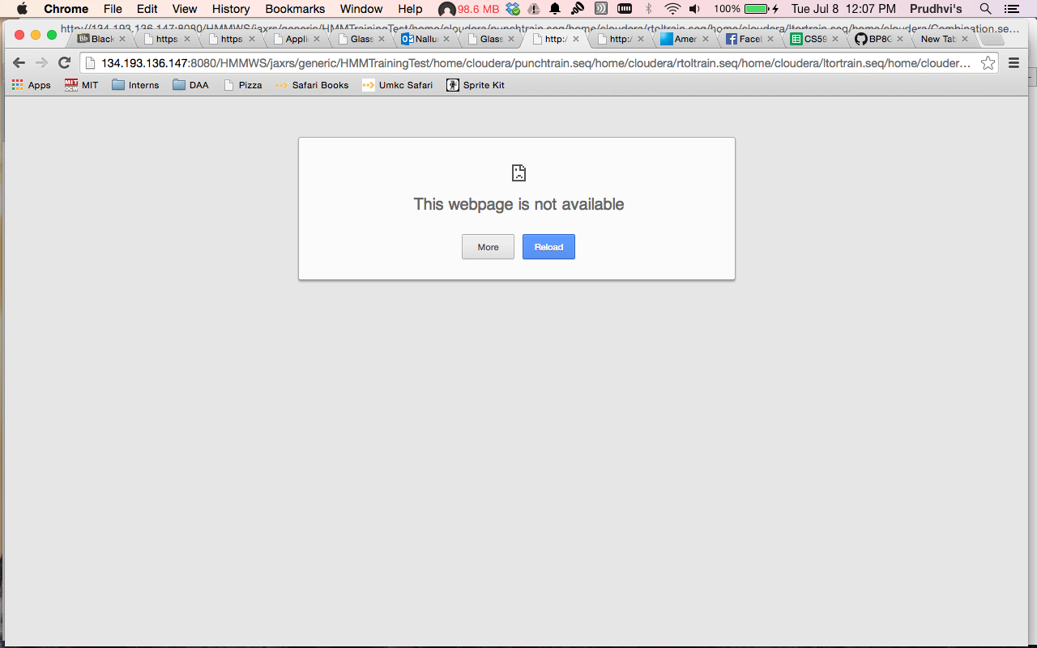

The glassfish on VM2 is not working so I tried to do in local machine.

The HMMWS war file is uploaded into the local glassfish server and deployed

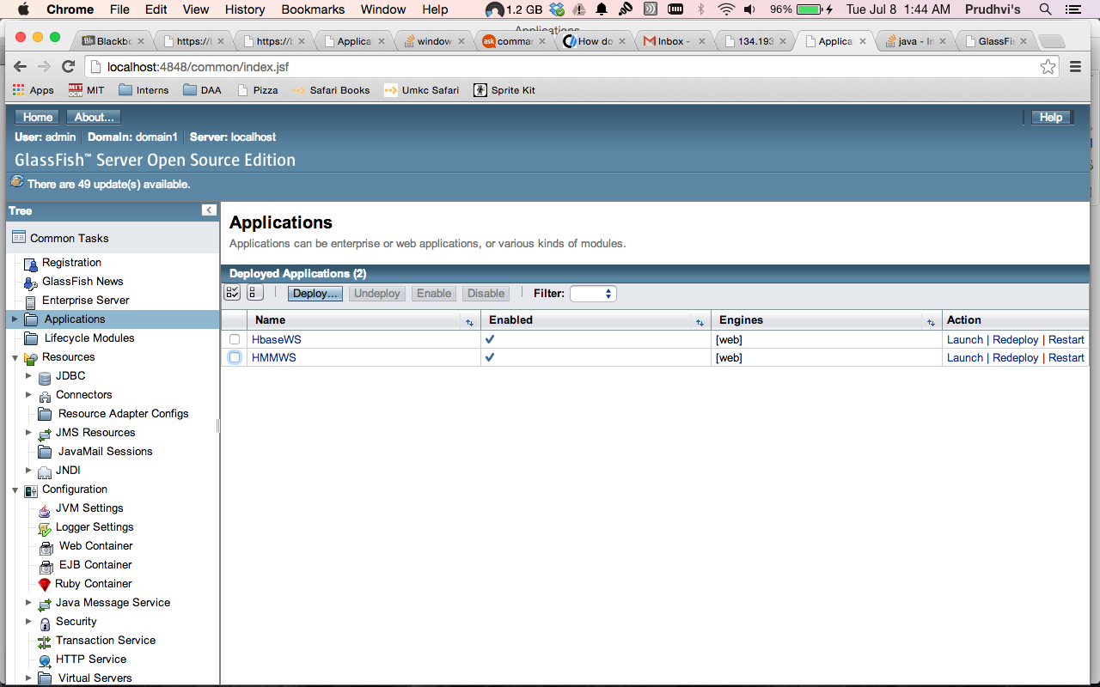

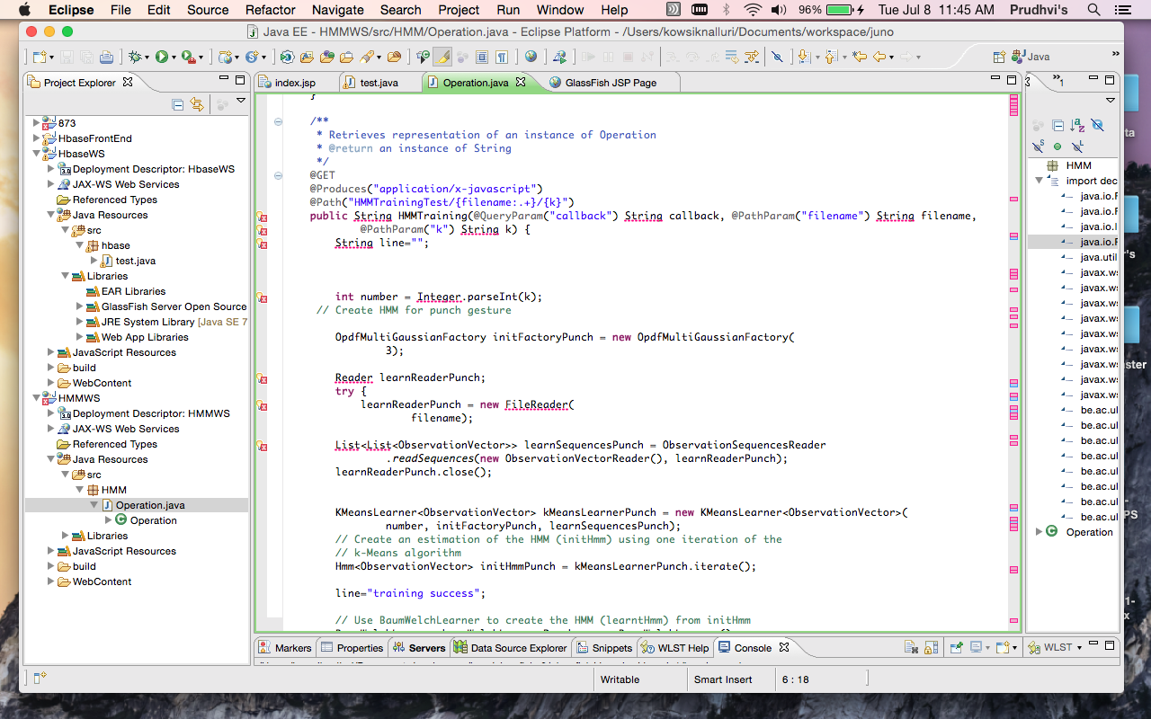

but the glass fish server is showing some internal issues to convert raw data into the sequence file.

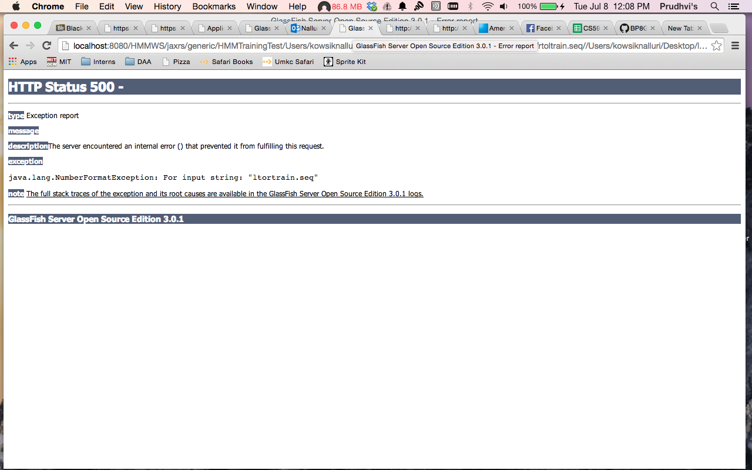

**Issues faced:**

The Glassfish server on VM2 is not working, unable to retrieve the outputs since the glassfish server is down.